**Types of Prescriptions**

Prescription laws vary by state, so it is important to check your state’s laws before starting your career to ensure that you are up-to-date and abiding by all relevant laws.

***************************************************************************************************************************

Prescription Requirements

* Patient Name
* Patient Phone Number
* Patient Date of Birth
* Physician’s office name, address, and phone number
* Physician’s signature
* Date written
* Medication name, strength, quantity, dose, and dosage form
* Administration route
* Directions for use – sig
* Refill information

***************************************************************************************************************************

Prescription Origins

Ways that prescriptions are delivered:

* (1)Written – Typed and printed, or handwritten.
* (2)Phoned – A prescriber may phone a prescription to a pharmacist.
* (3)Electronic – Whereby a prescriber sends a prescription in the form of an electronic transmission to the pharmacy.
  + Most pharmacies utilize a software package that links the doctor to the pharmacy.
* (4)Faxed – Sent via facsimile to a pharmacy from a prescriber.
  + The pharmacy must retain the transmission information located in the header and/or footer of the fax (aka… don’t’ tear off)

***************************************************************************************************************************

Dispense as Written Codes – DAW Codes

* 0 – Generic substitution permitted
  + It is both legal and commonplace to dispense generic in place of brand medications when available.
  + It is required by law that the words “generic for” be on the prescription label.
    - (Most software packages will enter this for you upon selecting the generic as the dispensed product).
* 1 – Brand name medically necessary
  + Doctor mandates that the pharmacy dispense the brand name medication.
* 2 – Patient request brand name
  + patient mandates that the pharmacy dispense the brand name.

***************************************************************************************************************************

Controlled Substances

* The Controlled Substance Act of 1970(CSA) is responsible for establishing the Drug Enforcement Administration (DEA), as well as forming drug schedules.
* The drugs and other substances that are considered controlled substances under the CSA are divided into 5 schedules.
* A controlled substance is placed in its respective schedule based on whether it has a currently accepted medical use in treatment in the United States and its relative likelihood of causing dependence.

***************************************************************************************************************************

Controlled Substance Factors

* Addiction
  + A complex disorder characterized by compulsive drug use.
  + While each drug produces different effects, they all share one thing in common: repeated use can alter the way the brain looks and functions.
* Drug Abuse
  + Habitual taking of addictive substances.
* Tolerance
  + When a patient’s reaction to a specific drug is progressively reduced, requiring an increased dose to achieve the desired effect.
* Withdrawal
  + Onset of symptoms that results from discontinued use of a substance.
* Psychological Dependence
  + Dependency of the mind to continue the same pattern of behavior.
* Physical Dependence
  + Awareness of withdrawal symptoms such as seizures, sweating, and tremors when use of a substance is discontinued.

***************************************************************************************************************************

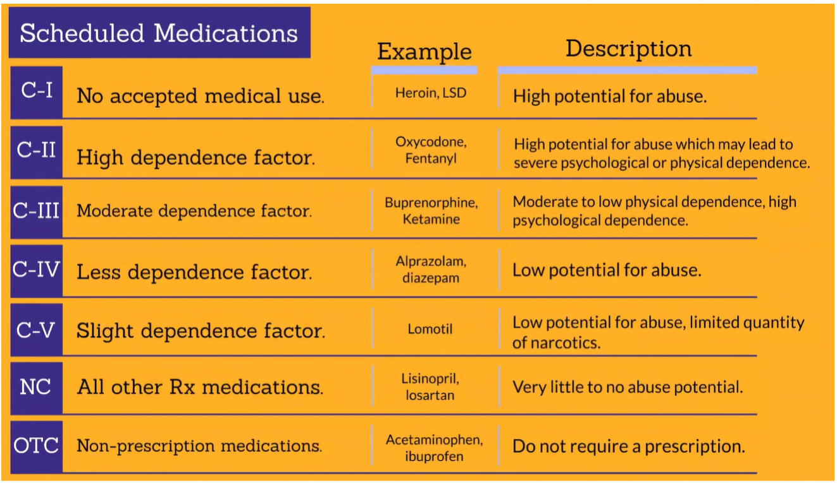

***************************************************************************************************************************

Prescription Refill Limits

* C-II Medications are not allowed to be prescribed refills. Each prescription is valid for one fill only.
* C-III – C-V Medications may be prescribed 5 refills, allowing the prescription to be filled for a total of 6 times.
* Non-controlled Medications may be prescribed up to one year’s worth of refills, allowing the prescription to be filled as many times as needed during that year.

***************************************************************************************************************************

Prescription Transfer Limits

* C-II Medications are not allowed to be transferred from one pharmacy to another.
* C-III – C-V Medications may only be transferred to another pharmacy once.
* Non-controlled Medications may be transferred unlimited times, so long as the prescription is not expired and has refills.

***************************************************************************************************************************

Prescription Expirations

* C-II prescriptions expire 6 months after the date they are written.
* C-II – C-V prescriptions expire 6 months after the date they are written.
* Non-controlled prescriptions expire 1 year after the date they are written.

***************************************************************************************************************************

**Workflow**

Drop Off 🡪 Data Entry 🡪 Adjudication 🡪 Dispensing 🡪 Verification 🡪 Pick-Up

***************************************************************************************************************************

**Drop Off**

* Drop off is one of two critical areas of the pharmacy where there is direct “face-to-face” interaction between the customer and yourself.
* Your actions, tone of voice, empathy, and respect for the patient set the tone for how the remainder of the transaction will take place.

Collecting Information

* Have you filled here before?
  + If yes, verify name, DOB, and ensure it is written on the prescription.
  + If not, collect the patient’s name, DOB, gender, allergies, address, phone number, and insurance information.
* Which doctor did you see?
  + Ask this question if you are not 100% sure who the prescriber is.
* Let me make sure we have this in stock.
  + This step ensures that the patient does not wait for a prescription that you do not have in stock at that time.
* When would you like to pick this up?
  + When giving an estimated wait time to a customer, be sure to consider other customers that are waiting, as well as the number of prescriptions in front of that patient.

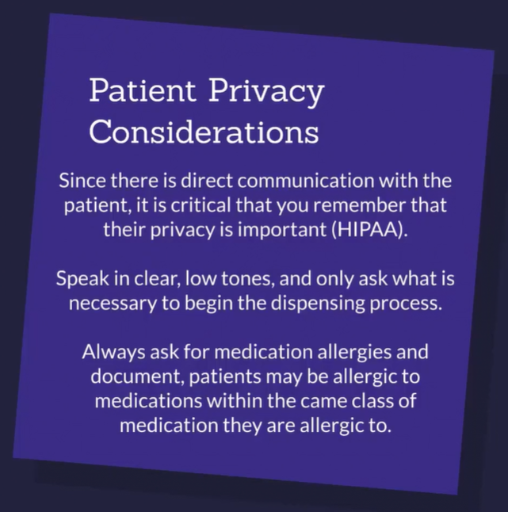

***************************************************************************************************************************

**Data Entry**

* This portion of the workflow focuses on the entering of the patient’s demographic and prescription information.
* Accuracy during this step is very important, as it can easily trigger errors downstream in the prescription preparation process.

5 Rights of Patients

1. Right Drug – The medication on the label AND the medication dispensed match the medication prescribed.
2. Right Route – The medication needs to be absorbed in the same route as prescribed.
3. Right Dose – The medication taken at each specified time should be the same dose as prescribed.
4. Right Time – The medication should be administered at the same time as prescribed.
5. Right Patient – The medication should only be dispensed to the patient it is prescribed to.

Interpreting Prescriptions

* The purpose of this section is to provide additional information for interpreting the prescriber’s information.
* Some of the sig codes you will see should be very familiar, others will be foreign to you, we’re here to help with that.

Components of a Sig

* Remember that while you will be checked by a pharmacist, it’s vital that you interpret the abbreviations and directions for use accurately.
* The patient will take the medication however you transcribe it onto the prescription label.

Dosage Form

* sol; soln – solution
* spr – spray
* supp – suppository
* susp – suspension
* syr – syrup
* tab(s) – tablet(s)
* tinc – tincture
* ung – ointment
* amp – ampule(s)
* cap(s) – capsule(s)
* cr – cream
* el; elix – elixir
* fl – fluid
* liq – liquid
* lot – lotion
* pulv - powder

Strength & System of Measurement

* L – liter
* mEq – milliequivalent
* mg – milligram
* mL – milliliter
* oz – ounce
* t; tsp – teaspoonful
* T;tbsp – tablespoonful
* u – unit
* cc – cubic centimeter (liq)
* fl oz – fluid ounce (liq)
* g; gm – gram
* gr – grain (sol)
* gtt(s) – drop(s)
* IU – international unit
* mcg – microgram
* kg - kilogram

Route of Administration

* ad – right ear
* as – left ear
* au – both ears
* ien – in each nostril
* IM – intramuscularly
* inj – inject
* IV – intravenous
* loc – locally
* po – by mouth
* od – right eye
* os – left eye
* ou – both eyes
* pr – rectally
* sc; subQ; SQ – subcutaneous
* SL – sublingual
* top – topically
* ud – use as directed
* vag - vaginally

Frequency

* hs – at bedtime
* noc – at night
* p – after
* pc – after meals
* PM – in the evening
* s – without
* stat – immediately
* tid – three times daily
* wk – weekly
* ac – before meals
* AM – in the morning
* ad lib – as often as necessary
* ASAP – as soon as possible
* atc – around the clock
* bid – twice daily
* c – with
* d – daily
* QD – once daily
* QOD – every other day
* QID – 4 times daily
* h; hr - hour

Miscellaneous

* HA – headache
* NR – no refills
* n/v – nausea/vomiting
* pa – pain
* s – without
* ss – one-half
* SS – single strength
* SSI – sliding scale insulin
* HS – half strength
* sob – shortness of breath
* NKDA – no known drug allergies
* a – apply
* aa – affected area(s)
* aff – affected
* BC – birth control
* c – with
* DC – discontinue
* DS – double strength
* EC – enteric coated
* ES – extra strength
* ug – until gone

Administration

* Oral – *Take* X tablet(s) by mouth.
* External – *Apply* to affected area(s).
* Suppository – *Insert* X into rectum/vagina.
* Drops – *Instill* X drops into both eyes/ears.
* Nebulizer – *Use* X vial(s) via nebulizer.
* Inhaler/Nasal – *Inhale* X puffs by mouth.

Number of Units

* Roman Numerals – ss, I, V, X, L, C
* Arabic Numerals – ½, 0.5, 1, 5, 10, 100
* Apothecary Symbols – 1 fluid dram (fl. dr.)

***************************************************************************************************************************

**Adjudication**

* Adjudication is the submission and subsequent response of a claim to an insurance company.
* In most pharmacies, it is almost instantaneous.

***************************************************************************************************************************

**Dispensing**

* Choosing the correct medication.
* Counting the appropriate number of dosage units.
* Preparing the prescription for sale.

Manufacturer’s Label

* Typically includes the medication’s brand name (if applicable), generic name, strength, quantity, manufacturer, lot number, expieration date, and NDC code.
* Prescription medications will have “RX Only” written on the label.
* Check your manufacturer’s label for special storage conditions.

Prescription Label

* Includes the medication name, strength, quantity, directions, patient’s name, prescriber’s name, prescription number, expiration date, refills remaining, pharmacy name, and pharmacy phone number.
* Labeling your prescriptions as you dispense them helps you to keep track of what vials contain what medications and prevents vials from getting labeled incorrectly.

Accuracy Scanners

* Commonly used to verify that the correct medication nis used to fill prescriptions.
* You will typically scan the medication bottle’s barcode, then scan the prescription barcode, this will validate that you chose the correct medication before you start counting.

Automatic Medication Counters

* Commonly used to streamline the dispensing process by eliminating the need to count medications by hand.
* These machines are faster than even the most seasoned technicians.
* Automatic medication counters also improve accuracy, ensuring that the correct number of doses is counted each time.
* Do not count sulfa medications or amoxicillin in these machines as some people are allergic to them and the dust may cross-contaminate other prescriptions.

Counting Trays

* When you count prescriptions for dispensing you will commonly use a counting tray and spatula.
* You should count by whatever pattern you are comfortable; some people count by 2’s, others by 5’s, do whatever makes you feel comfortable and accurate.

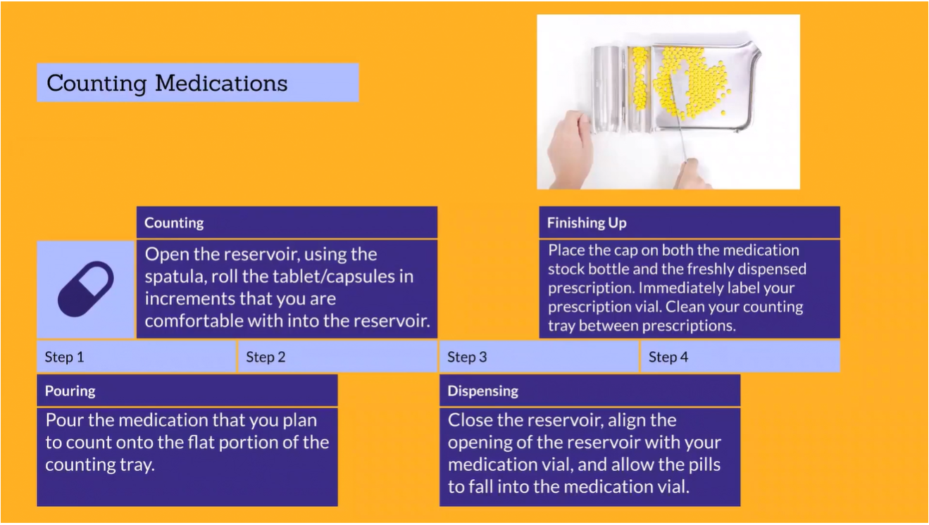

Safety Caps

* All prescriptions should be dispensed with child-proof safety caps by default except for nitroglycerin and non-oral dosage forms.
* Patients may opt-out of receiving safety caps on their prescriptions, in this situation, it should be documented in the patient’s chart for future dispensing’s.

Controlled Medications

* Medication name, strength, quantity, prescription number, and patient name should be logged before dispensing.
* Always double count controlled medications to ensure you dispensed the correct quantity.

Liquid Medications

* Always ensure that you select the correct liquid enclosure.
* Pour the medication with the label on the manufacturer's bottle facing up to avoid the label getting soiled if there is spillage.
* Dispense with a compliance aid capable of dispensing the correct dose.

Auxiliary Labels

* Useful for providing information to the patient about how to take their medications.
* All suspensions should have a “Shake Well” auxiliary label.
* Other common auxiliary labels include:
  + Take with food.
  + May cause drowsiness.
  + Keep refrigerated.

***************************************************************************************************************************

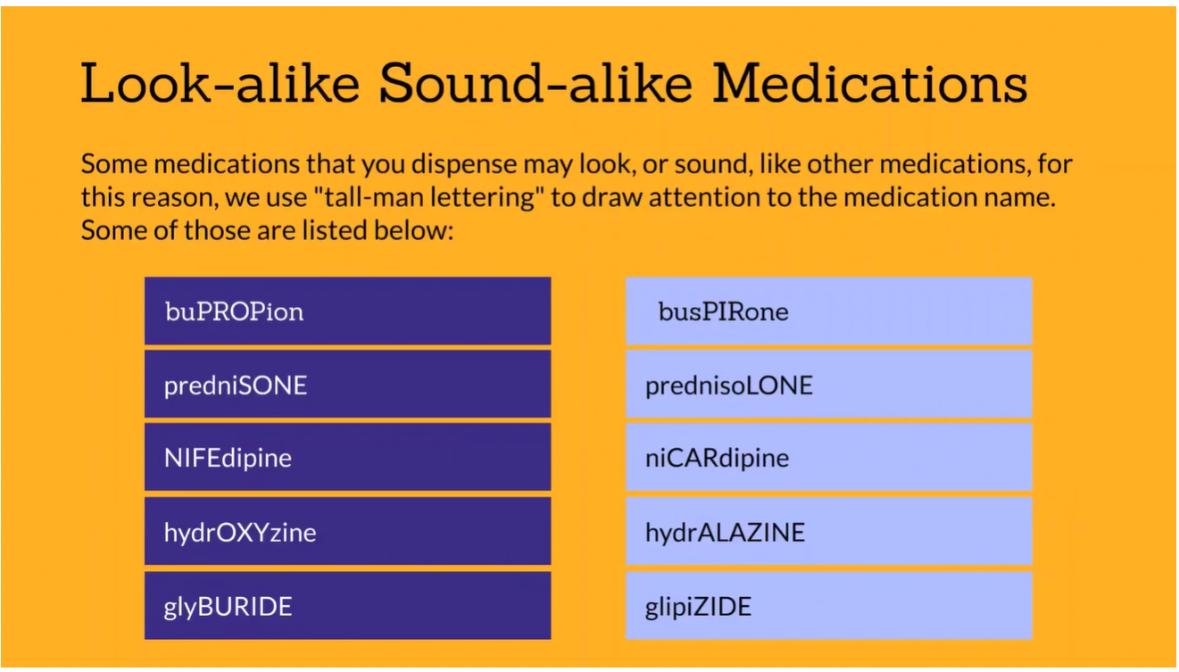

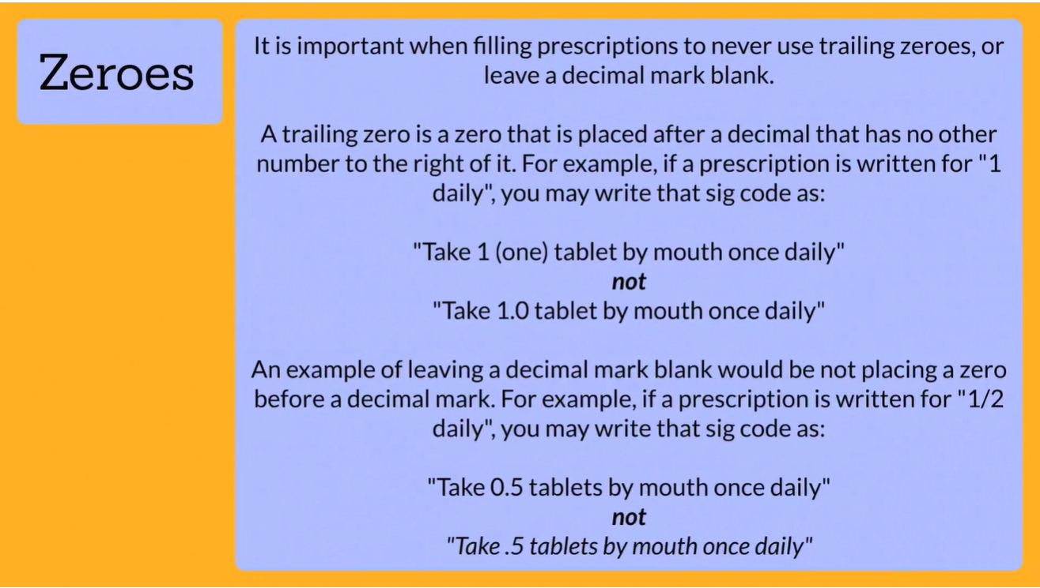

***************************************************************************************************************************

**Common Prescription Errors**

* Prescription errors can lead to unintended consequences, all the way up to death. For this reason, it’s important to be able to prevent common prescription errors.

Missing Prescription Requirements

* Sometimes a physician may forget to include part of a prescription such as his signature, or the number of tablets to dispense.
* Solution: Alert your pharmacists of the missing information.
* Depending on the type of prescription, the pharmacist may call the physician for clarification, or ask the patient for a new prescription with the needed information.

Incorrect Medication

* Medications may look or sound alike causing them to be confused for one another.
* This is extremely dangerous as a patient could get a medication that they are not prescribed.
* Solution: Double check the name of the medication as well as the NDC code prior to dispensing the prescription.
* Technology such as barcode scanners can help to eliminate these errors.

Expired Medication

* Medication that is going out of date can slip through the cracks while doing inventory causing the patient to receive a medication that is expired.
* Solution: Follow your pharmacy’s standard operating procedures (SOPs) for checking expiration dates.
* A good rule of thumb is to check all inventory for out-of-date medication at least once a month and pull medications going out of date three months in advance.

Incorrect Patient

* Patients dropping off prescriptions may have the same or similar name as other patients.
* This can lead to a prescription getting filled for the wrong person.
* Solution: Always verify your patient's name and date of birth at both drop off and pickup.
* This will ensure that the correct patient gets their medication each time.

Incorrect Directions

* The sig of a prescription can be a little difficult to read resulting in the wrong directions being printed on the patient's label.
* Solution: Ask clarifying questions for any confusing sig codes.
* Start by asking your fellow technicians, then your pharmacist, and ultimately if you are still unable to decipher the prescription’s directions, call the prescriber’s office for clarification, documenting any information you receive.

***************************************************************************************************************************

**Other Considerations**

* Identifying patients for counseling.
* Hygiene of your workspace.
* Reference manuals that you may need for information.

Counseling

* This process involves the pharmacist talking to the patient for any variety of reasons to ensure they feel comfortable taking their medications.
* As a pharmacy technician, you can help your pharmacist identify patients that may need counseling.
* Examples of patients that may need counseling on their prescriptions include those that are:
  + Receiving new prescriptions.
  + Late refills on old prescriptions.
  + Reporting adverse effects from a prescription.
  + A candidate for vaccination (flu annually, shingles/pneumonia in elderly population).
  + Receiving a change to their prescriptions (dose change, frequency change).
* **Do not counsel the patient yourself**, even if the pharmacist is busy.
* **Ask** the **patient** if they would like to **have** the **pharmacist** **call** **them** to discuss any concerns.
* Continuously work to **identify patients that may need counseling** and refer them to the pharmacist.
* Offer every **patient** the **opportunity** to **speak** **with** the **pharmacist** by asking “**What questions do you have for our pharmacist today?**”.

Pharmacy Hygiene

*Ensures a safe workspace.*

* Dispose of vials and medication bottles in the appropriate place ensuring they are not on the floor or counters.
* Regularly remove shredding/trash to prevent clutter and disorganization.
* Clean common surfaces such as telephones, keyboards, and pill counting trays regularly with alcohol.
* Follow your pharmacy’s standard operation procedures (SOPs) for end-of-day cleaning policies.

Workspace Hygiene

*Ensure medication safety.*

* Aim to only work on 1 prescription with 1 medication at a time to prevent dispensing the wrong medication for the wrong prescription.
* Clean your workstation often with alcohol to prevent contamination.
* Clean your counting tray between prescriptions to prevent cross-contamination.
* At the end of your shift, be sure to return all supplies to their designated location for the next technician.

Hand Hygiene

*Ensures YOUR safety.*

* Wash hands after using the restroom as well as any other time hands are soiled.
* Use hand sanitizer often during your shift.
* Hand hygiene keeps medications from penetrating/irritating the skin, should your skin contact them during dispensing.
* Hand hygiene prevents illnesses from spreading from objects to you, as well as prevents illnesses from spreading from you to others, as you will see patients with poor immune systems.

Reference Manuals

* Sometimes, you may fill a prescription for a patient or medication that you aren’t typically used to.
* In this event, you may need to use a pharmacy reference manual.
* Common pharmacy reference manuals and their uses include:
  + Facts and Comparisons – Drug information
  + Physician’s Desk Reference (PDR) – Drug information and package inserts
  + American Drug Index – Drug information
  + Handbook of OTC Drugs – OTC Drug information
  + US Pharmacopeia - Drug standards
  + Handbook of Injectable Drugs – IV solutions, drug-drug compatibilities
  + Red Book – Average wholesale pricing
  + Orange Book – Therapeutic equivalencies

***************************************************************************************************************************